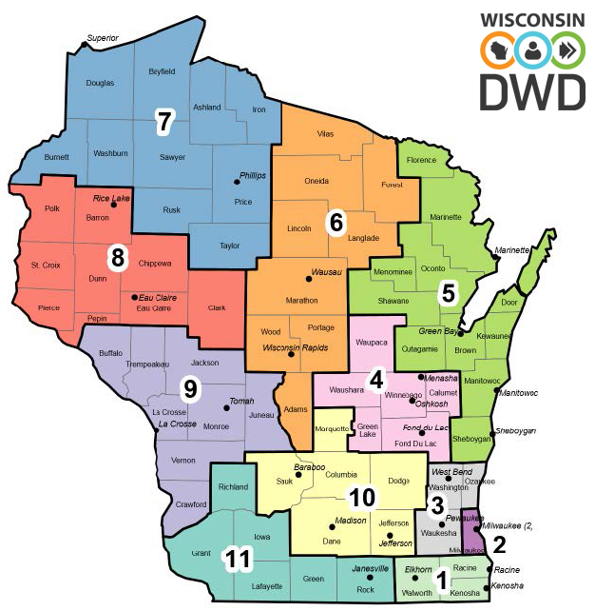

WDA | REGION | NAME | PHONE | EMAIL
1 | Southeast | Kim Patterson | (262) 956-6919 | Kim.Patterson@dwd.wisconsin.gov
1 | Southeast | Sybrina Thompson | (262) 548-5853 | Sybrina.Thompson@dwd.wisconsin.gov
2 | Milwaukee | Connie Georgetta-Krystyn | (414) 750-0204 | Connie.GeorgettaKrystyn@dwd.wisconsin.gov
2 | Milwaukee | Edilma Rodriguez | (262) 790-2377 | Edilma.Rodriguez@dwd.wisconsin.gov
3 | WOW | Sandy Murphy | (262) 956-6858 | Sandra.Murphy@dwd.wisconsin.gov
4 | Fox Valley | Jenn Mueller | (920) 404-6845 | Jeannette.Mueller@dwd.wisconsin.gov
5 | Bay Area | Brian Pelon | (920) 930-6560 | Brian.Pelon@dwd.wisconsin.gov
5 | Bay Area | Stacy Scheibl | (920) 930-6543 | Stacy.Scheibl@dwd.wisconsin.gov
6 | Northcentral | Gail Hurd | (715) 679-5526 | Gail.Hurd@dwd.wisconsin.gov
7 | Northwest | John Carlson | (715) 679-5604 | John.Carlson@dwd.wisconsin.gov
8 | West Central | Marcella Lynch | (715) 679-5612 | Marcella.Lynch@dwd.wisconsin.gov
9 | Western | Iryna Mohilevets | (608) 405-4604 | Iryna.Mohilevets@dwd.wisconsin.gov
10 | South Central | Jennifer Brikowski | (608) 405-4404 | Jennifer.Brikowski@dwd.wisconsin.gov
11 | Southwest | Lesley Luna | (608) 901-5694 | Lesley.Luna@dwd.wisconsin.gov
11 | Southwest | Michele Eggers | (608) 901-5693 | michele.eggers@dwd.wisconsin.gov

